SOURCE ID | BASED URL
917566301 | https://journals.aai.org/immunohorizons
76468799 | https://journals.aai.org/jimmunol
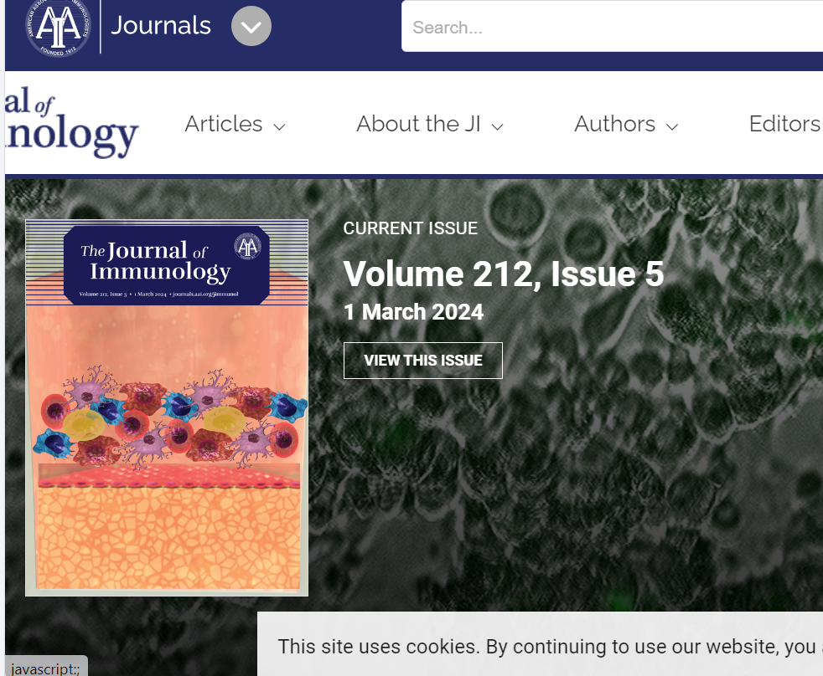
Go to the based url so the landing page will appear like below
Select current issue

Meta data capture as below
Capture Publication month,date,year details
Capture publication month,date and year details
Capture volume issue details
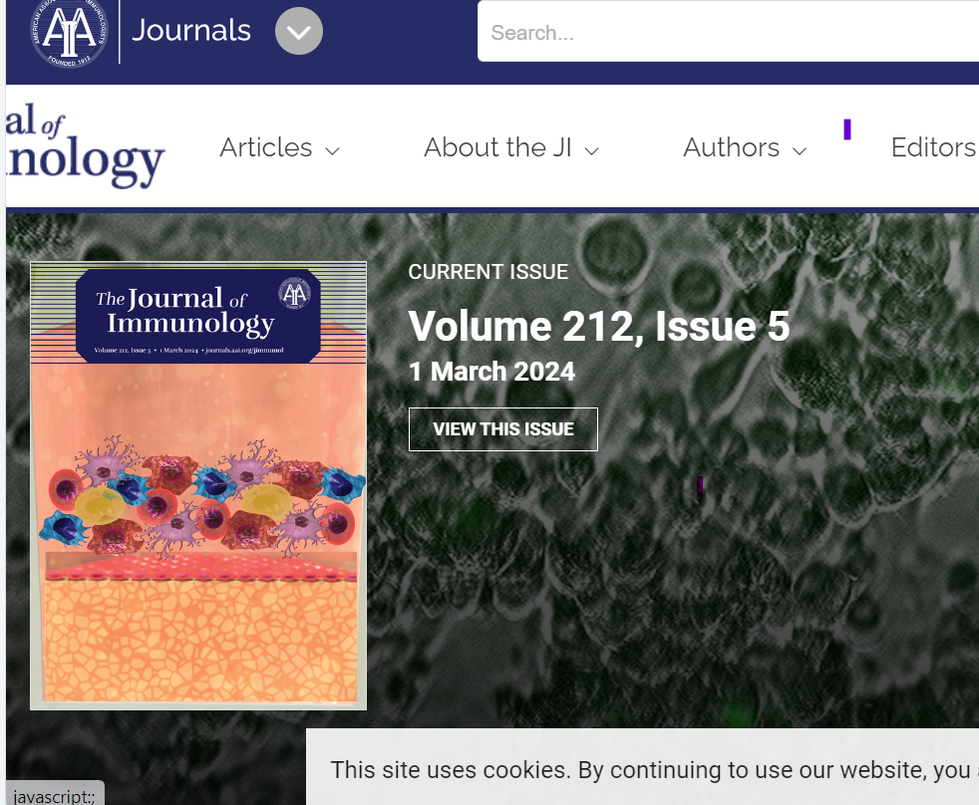

Then click view the issue button then it will direct to article set.
Articles will appear like below.

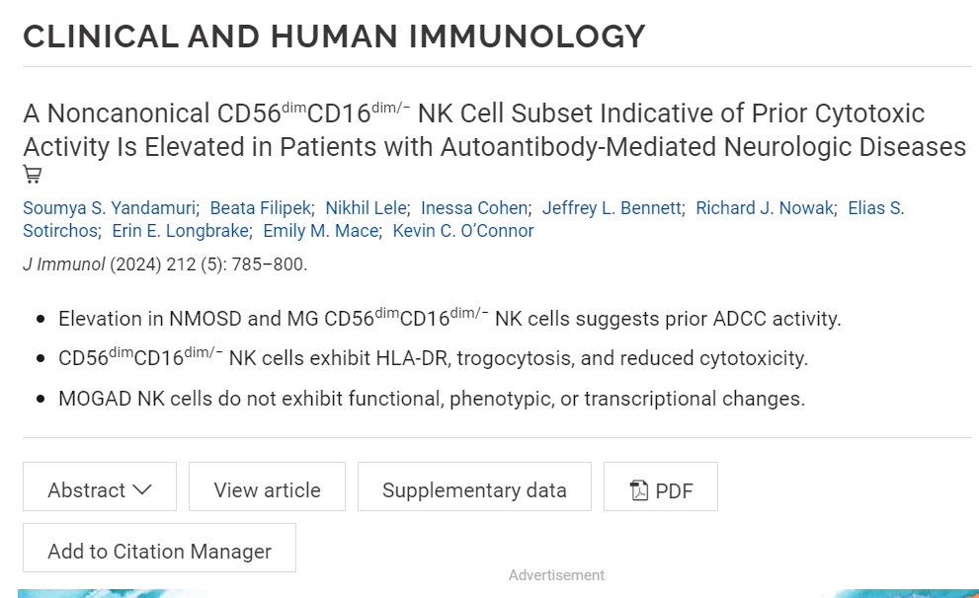
Capture article page range from here
Capture article title from here

Then click pdf button so link will direct to the below web page

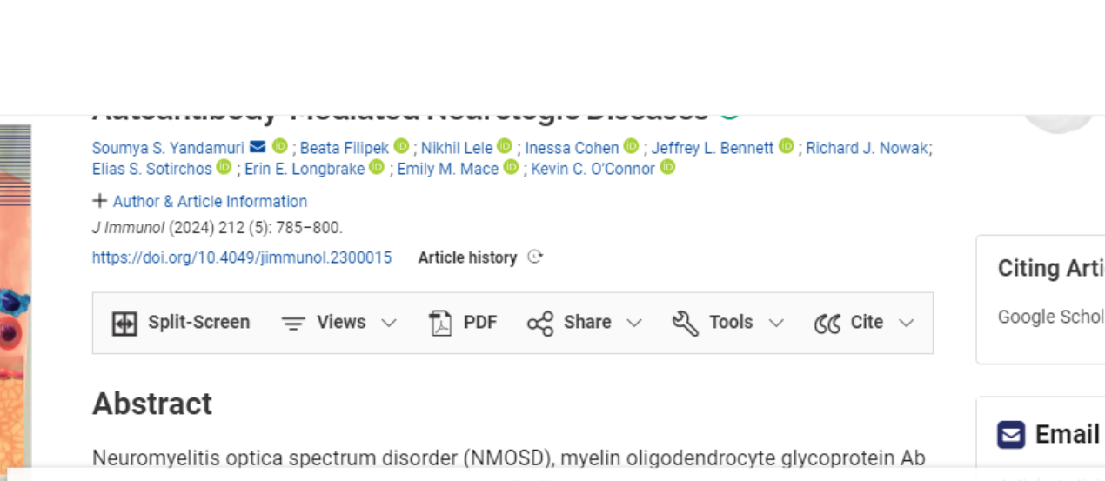
Click pdf button from here
Take doi from here
Then it will direct to the pdf like below then download the pdf.
